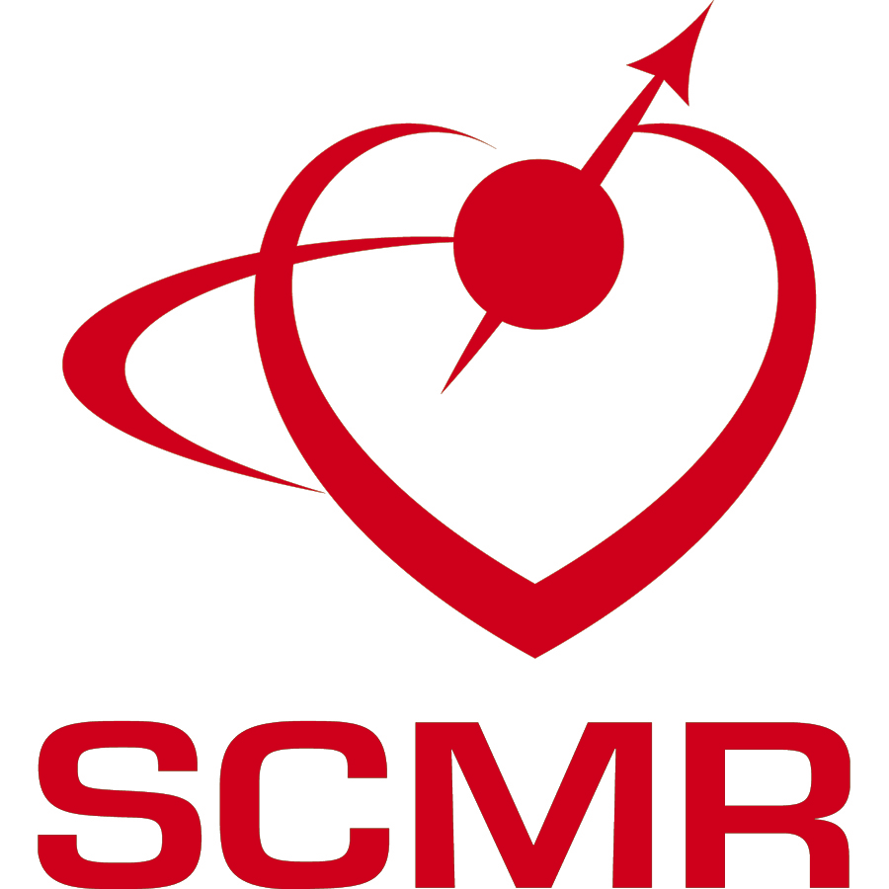
SOCIETY FOR CARDIOVASCULAR MAGNETIC RESONANCE

SCMR Data Access Application

Researchers must complete this form when submitting an application for access to the SCMR Registry database. Applications must be emailed to hq@scmr.org, subject: “[Name], SCMR Data Access Application.”

Application Details
The purpose of the application is to provide the information needed by the SCMR Registry Committee to determine whether your proposed research project is feasible and aligned with the mission and priorities of SCMR. The Registry Committee will also evaluate your proposed project for any potential overlap with other proposed or ongoing projects and will inform you and encourage collaboration if that is the case. If you are not a contributor of data to the Registry, we recommend that you partner with one of the contributing centers in the formulation and execution of your project. A list of those centers and investigators can be found on the SCMR Registry webpage. A formal search of the SCMR Registry for relevant data will be required to complete this application. If you have not yet performed a formal search for the data required for this project, please submit a Search Request and work with the Registry Committee to execute the search and generate the information required for item F below.

Please fill out the following fields to provide the Registry Committee with a brief synopsis of your proposed research plan (i.e., a description of the aims, methods, and intended outputs).

Please note that if your access is approved, the data requested must be used solely for the purpose(s) outlined in the study and will not be approved for use for any other purpose. Investigators who have been previously approved for data use must submit a new application to conduct another study (even if the subject matter is related) and receive approval from the Registry Committee and the individual sites prior to using any data for a new project.

Applications are scored on a 9-point scale in the following four categories. Please refer to the score sheet and review process posted on the website.

- Alignment with the SCMR Mission: To improve cardiovascular health by advancing the field of CMR, or alignment with a specific request for application (RFA).
- Potential impact on the field and utilization of CMR.
- Feasibility of the project based on Registry data available, work required by contributing centers, and resources available to complete the project.
- Investigators: The team possesses the skills, expertise, and resources to accomplish the project.

All below fields are required.

- Project title:
Click or tap here to enter text.
- Research objectives (200 words max):
Click or tap here to enter text.
- Briefly state the potential novel results that could lead to improved patient care or understanding of disease (50 words max).
Click or tap here to enter text.
- Principal and co-investigator(s) (names and institutions):
Click or tap here to enter text.
- The background and scientific rationale of the proposed research project (500 words max):
Click or tap here to enter text.
- List the search criteria used to identify the project data and the results of the search, including a list of sites and the number of cases satisfying the search criteria from each site. If you have not yet performed a formal search of the Registry database for the data required for this project, please submit a Search Request and work with the Registry Committee to execute this search.
Click or tap here to enter text.
- Provide a brief description of the research methods (500 words max).
Click or tap here to enter text.
- What is the estimated duration of your project, in months? Describe the expected project timeline and milestones. If you wish to provide an additional supporting documentation (e.g., Gantt chart, conference abstracts, previous publications, etc.), please attach as PDF files).
Click or tap here to enter text.
- Please provide a brief lay summary of your research project in plain English, stating the aims, scientific rationale, project duration, and public health impact (200 words max).
Click or tap here to enter text.
- Will the research project result in the addition or clean-up of registry data, such as advanced image analysis results, patient history data, patient outcomes data, etc., which may be of significant utility to other researchers?
☐Yes
☐No
- Please list any new data fields you anticipate will be contributed to the database over the course of completing your study.
Click or tap here to enter text.

Please note that you are required to publish (or make publicly available) your results, and add back to the SCMR Registry, using the provided Registry user interface, corrections and additions to the existing data, and any important derived variables, patient history, and patient follow-up data that are generated over the course of your study.

In addition, you will be required to submit to SCMR the following via email to hq@scmr.org:
- A description of the methods used to generate any derived variables
- The underlying syntax/code used to generate the main results of the paper
- A short layman’s description summarizing your findings
These must be provided within six months of each publication or within 12 months of the project end date (whichever comes first). We also ask that you send us at hq@scmr.org a copy of your manuscript at least one month prior to submission (via email at hq@scmr.org) and alert us if there are any ethical or contentious issues surrounding the findings.

- Will the research project necessitate data gathering that requires patient identification, e.g., patient history or patient outcome data?
☐Yes
☐No

Please note that the SCMR Registry contains no patient health information (PHI), and there is no possibility of reidentification of patients within the SCMR Registry database. Access to PHI can only take place at the contributing center with appropriate Institution Review Board (IRB) or ethics board approvals.

- Please list any potential sources of bias and how you plan to manage these. If there are no potential sources of bias, enter “N/A.”
Click or tap here to enter text.

Name and credentials: Name, credentials
Title: Title
Institution: Institution
Email address: Email address
Date: Select the date of submission

